Turning Point Paper
Chapter Seven is fraught with tension. Up to this point, Gatsby and Daisy have behaved as if their actions were free of consequence; however, their romance has been suspended in limbo and limbo is ultimately unsustainable. The chapter's culminating action sees Myrtle die and Gatsby take the blame.
Your Challenge: Scour Chapter Seven and consider which moment had the single biggest impact on the story's direction. What line, paragraph, or half page was arguably the turning point? Once you've identified this moment, do the following:
1. Rewrite the passage, aiming for the biggest impact. To the best of your ability, mimic Fitzgerald's writing style so that your passage could, presumably, be slipped into the original. Use one original line to start your passage; from there, rewrite the moment so that it redirects the story.
2. Write two meticulously crafted paragraphs unpacking your choice. In paragraph one, explain why/how your selected passage worked as the turning point; what made it so influential? Next, in paragraph two, explain how your passage would redirect the story. If your passage were a part of the narrative, what would happen after?
*This assignment should be typed, MLA format.
GRADING:
- 25 points for thoughtful rewritten passage.
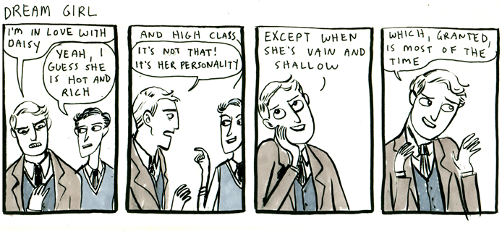
- 25

