The Great Gatsby Reading Packet
Overview
Date | When I Come to Class I Should…
 | Be Done Reading | Have Completed
Mar. 23 | (Check out book)
Mar. 25 | Chapter 1 | Movie scene critique Part 2 (20 pts)
Mar. 29 | Chapter 2 | Creative response 1 (20 pts)
Mar. 31 | Chapter 3 | Creative response 2 (20 pts)
Spring Break
Apr. 11 | Chapter 4 | Creative response 3 (25 pts)
Apr. 13 | Chapters 5–6 | Creative response 4 (25 pts)
Apr. 15 | Chapter 7
Apr. 19 | Chapter 8
Apr. 21 | Chapter 9 | Character tracer chart (30 pts)
Apr. 25 | DBQ (50 pt)
Apr. 27 |  | Turning point paper (50 pts)
Apr. 29
May 3 |  | Interior monologue & analysis (100 pts)

Creative Response Instructions
Response # 1
In Chapter Two, Nick accompanies Tom and Myrtle, to a party. Tom’s behavior suggests an utter disregard for Daisy. At the end of the chapter, however, the following takes place:
“Some time toward midnight Tom Buchanan and Mrs. Wilson stood face to face, discussing in impassioned voices whether Mrs. Wilson had any right to mention Daisy’s name.
‘Daisy! Daisy! Daisy!’ shouted Mrs. Wilson. ‘I’ll say it whenever I want to! Daisy! Dai—‘
Making a short deft movement, Tom Buchanan broke her nose with his open hand” (41).
Consider Tom’s actions. What could possibly have motivated the physical abuse? As if you’re Tom, write a journal entry recounting the night. Discuss what you thought about the party, the guests, and the hit.

Response # 2
It is in Chapter Three that we finally meet, in person, the famous Mr. Gatsby. Amidst rumors of murder and German spying escapades, Gatsby takes shape.
In a meticulously crafted argument paragraph, argue whether Gatsby is more likely to become the book’s hero or villain. Use at least one direct quote to situate your stance.
Response # 3
In Chapter Four, Gatsby’s complex history with Daisy is revealed. While Gatsby was stationed at the base near Daisy’s home, Gatsby and Daisy fell in love. Although Daisy chose to marry Tom after Gatsby left for the war, Daisy drank herself into numbness the night before her wedding after receiving a letter from Gatsby.
Consider what you know about their relationship and the surrounding circumstances. As if you’re Gatsby, write the letter that Daisy received. Then, in a separate paragraph, defend your letter’s content. Why does your letter make the most sense within the book’s context?

Response #4
It is in Chapter Five that we finally witness Gatsby and Daisy’s reunion. Their meeting is emotionally tumultuous, swinging from the severely awkward to the severely happy. Because we are limited to Nick’s thoughts alone, we can only assume how Daisy and Gatsby are feeling based on Nick’s observations.
Select a passage from Chapter Five (at least one page) and rewrite it from either Daisy or Gatsby’s perspective. Really get inside their heads to explore how they experienced the encounter, emphasizing ideas the reader may have missed in the original reading.

Turning Point Paper
Chapter Seven is fraught with tension. Up to this point, Gatsby and Daisy have behaved as if their actions were free of consequence; however, their romance has been suspended in limbo and limbo is ultimately unsustainable. The chapter's culminating action sees Myrtle die and Gatsby take the blame.
Your Challenge: Scour Chapter Seven and consider which moment had the single biggest impact on the story's direction. What line, paragraph, or half page was arguably the turning point? Once you've identified this moment, do the following:
1. Rewrite the passage, aiming for the biggest impact. To the best of your ability, mimic Fitzgerald's writing style so that your passage could, presumably, be slipped into the original. Use one original line to start your passage; from there, rewrite the moment so that it redirects the story.
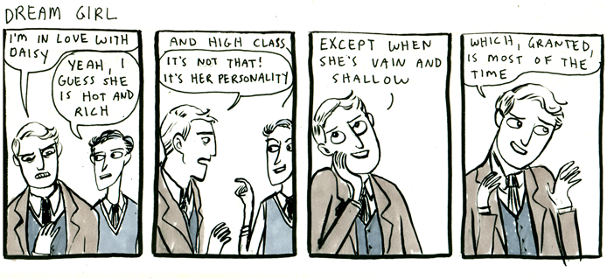
2. Write two meticulously crafted paragraphs unpacking your choice. In paragraph one, explain why/how your selected passage worked as the turning point; what made it so influential? Next, in paragraph two, explain how your passage would redirect the story. If your passage were a part of the narrative, what would happen after?
*This assignment should be typed, MLA format.
GRADING:
- 25 points for thoughtful rewritten passage.
- 25 points for two reflective paragraphs that critically unpack choices.
Interior Monologue Final Assessment

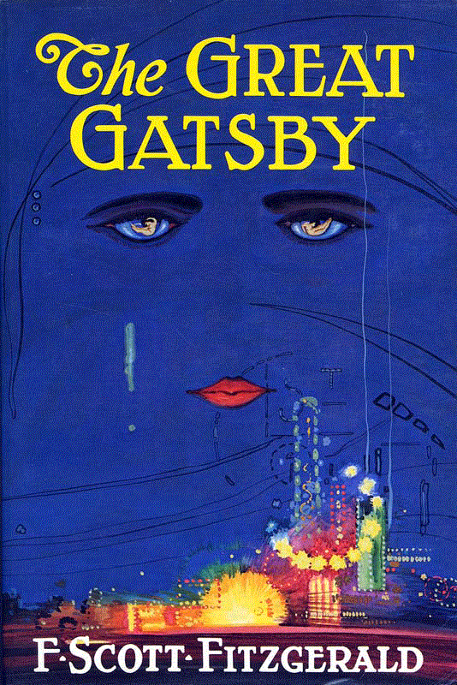
Throughout our study of The Great Gatsby, you have been evaluating how the author develops characters and uses them to reveal themes. You have traced your character's progression throughout the book and you have had a chance to delve into your character's thoughts and motivations.

Part 1: Write an Interior Monologue (50 pts)

Select a, "Hot Spot" for your assigned character. Think about the facets of his/her personality that help reveal theme. For example, if you think a prominent theme is that living in the past will only bring unhappiness, you may want to look at Gatsby and Nick's conversation at the end of chapter six.

Write a one to two minute monologue (about one page) from the perspective of this character that shows how this character contributes to a theme of the novel.

Your monologue must include:
- A brief sentence of context, so your audience understands where in the novel your monologue is situated
- One line from the book that the character actually says that launches you into your monologue
- A connection to a pivotal theme of the novel
- One metaphor
- Carefully selected diction that reveals the tone of your piece

Part 2: Analyze Your Monologue (50 pts)

In two meticulously crafted paragraphs, explain the analytical choices you made while you constructed this monologue.

Your first paragraph should explain (with evidence from your text) what choices you made in your own writing. What diction did you use and how did it help convey your tone? What theme emerged as a result of your monologue and how did you develop it?

Your second paragraph should explain how your creative adaptation provides new insight into the text or the theme. How does your monologue's writing develop our understanding of the source text, The Great Gatsby? How does it alter or expand it to create a new or enhanced message?
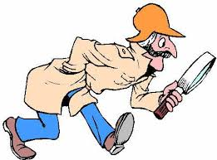
Character Tracer Chart
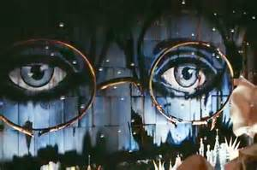
YOUR MISSION: Your goal is to uncover the inner workings of your subject. What motivates him or her? What are your subject’s strengths and weaknesses? What does he or she want more than anything else? What makes your subject tick? The more information you’re able to uncover, the easier your, “case,” will become. Good luck!

You have been selected to trace the character ______________________________________
Instructions: As you read, look for quotes from the text that help create your assigned character's personality. Remember, these traits don't always have, "direct" characterization that explicitly describes your character. Clues may be indirect (speeches, thoughts, actions, faction expressions, their effect on other characters, etc.). Record the quote and explain what it tells you about your character.
Quote and Page Number: | Type of Characterization (Direct or indirect? Speech, action, thought, etc.): | Inferences about character we can draw based on the quote:
Quote and Page Number: | Type of Characterization (Direct or indirect? Speech, action, thought, etc.): | Inferences about character we can draw based on the quote:

