Name: Per:
My “Go To” Reading List
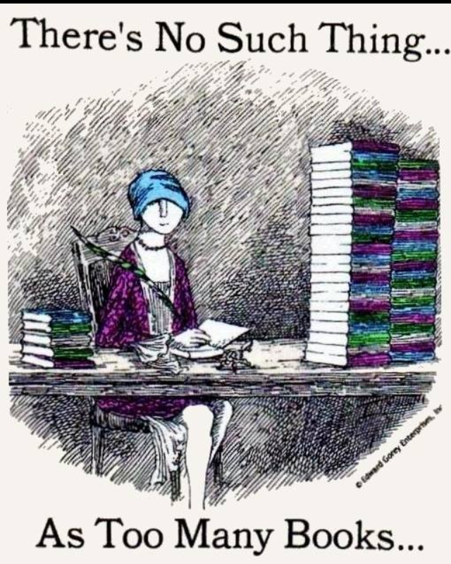
Spend the rest of the class period in the library compiling a list of potential books you could read for the reading challenge. You’ll notice there are specific tasks that you must do so that your list is rich with variety. Just because you write a book down doesn’t mean you have to read it as part of the challenge. This is a tool for you to use if you get stuck and don’t know what to read next. Complete this by the end of the period and turn it in to Mrs.Craft (you will get these back once I grade them).
Get recommendations from at least 5 different classmates (include title, author and classmate recommending the book).
1.____________________________________________________________________
2.____________________________________________________________________
3.____________________________________________________________________
4.______________________________________________________________________
5.______________________________________________________________________
6.______________________________________________________________________
7.______________________________________________________________________

Use a book recommendation site such as whatshouldireadnext.com or yournextread.com to find at least 3 books that are similar to a book you have enjoyed before (include title and author).
1.______________________________________________________________________
2.______________________________________________________________________
3.______________________________________________________________________
4.______________________________________________________________________
5.______________________________________________________________________

List 3 of your hobbies or interests and find a nonfiction book on at least 1 of these topics.
1.____________________________________________________________________
2.____________________________________________________________________
3.____________________________________________________________________

Look up at least 3 books from Mrs. Craft’s list of books other students have recommended.
1.______________________________________________________________________
2.______________________________________________________________________
3.______________________________________________________________________
4.______________________________________________________________________
5.______________________________________________________________________

Browse the Library—the shelves, the lists, etc. to find at least 3 potential books
1.______________________________________________________________________
2.______________________________________________________________________
3.______________________________________________________________________
4.______________________________________________________________________
5.______________________________________________________________________

