Julianne Craft
Mrs. Craft
English 10
October 14, 2015
The Healthy, Happy Cereal
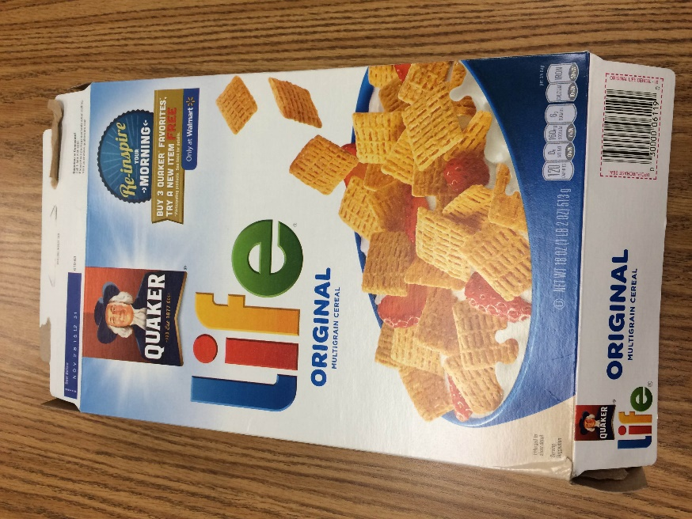
Everyone wants to be happy and nearly everyone wants to be healthy, so focusing on health and happiness is a good way to sell breakfast cereal. The packaging designers for my 18 oz. box of Life cereal used many details to send the message that buying and eating this cereal will help you be healthy and happy. A few explicit messages contribute to this main claim; however, it is mostly communicated through implicit messages.
The explicit messages on the front of this box are short and sweet. This is probably because people will not take the time to read long paragraphs on a cereal box. The first explicit message says that this cereal is “original” and “multigrain.” These are both words that communicate the idea of healthiness. Another explicit message is in the upper right corner where it says, “Re-inspire your morning.” These three words send a very positive and happy vibe. They suggest that if you eat this cereal you will feel inspired and have a good start to your day.
This message of health and happiness is reinforced by many of the other details on the box that implicitly suggest good health and happy times. For example, the box has a backdrop fo blue skies and sunbeams. These details are usually associated with happiness, so consumers glancing at the box might infer that this cereal brings happiness. The main picture on the box is a bowl of cereal with milk and strawberries. The milk and strawberries are of course not included in the box, but the designers have included them to imply that the cereal is healthy and part of a balanced nutritious breakfast. The other main picture on the front of the box is the Quaker logo. This image show an old-fashioned man who is smling. Once again, his smile implies that this is a happy cereal and his outfit suggest good old-fashioned farmers who grow healthy food.
Altogether, there are many carefully chosen details on this cereal box to send a mesage. A hurried shopper in the grocery store only needs to glance at it for a moment to subconsciously get the message that this cereal is healthy for you and will make you happy.

