MLA Paper Format

Paper Format
- Type your paper on standard, white 8.5 x 11-inch paper.
- Use a legible font (e.g. Times New Roman). The font size should be 12 pt.
- Double-space the text of your paper.
- Leave only one space after periods or other punctuation marks.
- Set the margins of your document to 1 inch on all sides.
- In the upper right-hand corner, create a header that includes your last name, followed by a space with a page number. Numbers all pages consecutively using Arabic numerals (1, 2, 3, etc.).
- Indent the first line of paragraphs one half-inch from the left margin by using the Tab key.

Formatting the First Page of Your Paper
- In the upper left-hand corner of the first page, list your name, your instructor's name, the course, and the date. Be sure to use double-spaced text.
- Double space again and center the title. Do not underline, italicize, or place your title in quotation marks. Do not write your title in all capital letters. Instead capitalize the first letter of all major words.
- Double space between the title and the first line of the text.

Sample Page
Here is a sample of the first page of a paper in MLA style:
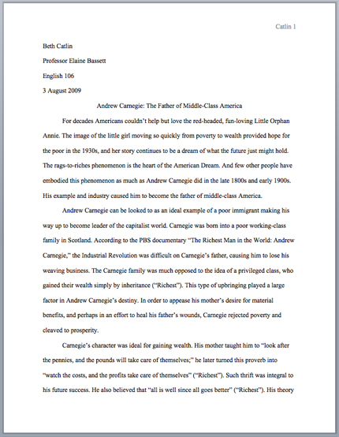
The First Page of an MLA Paper

