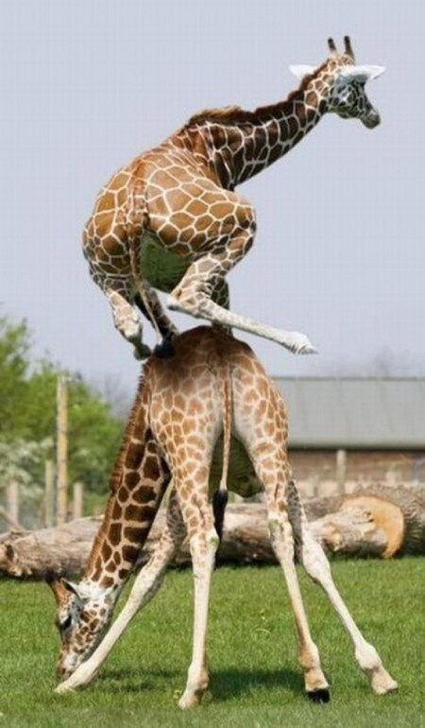
Write a story about the image.
Circle all the verbs.
Change one verb to a more interesting verb.

