Imagine that this procedure really exists.
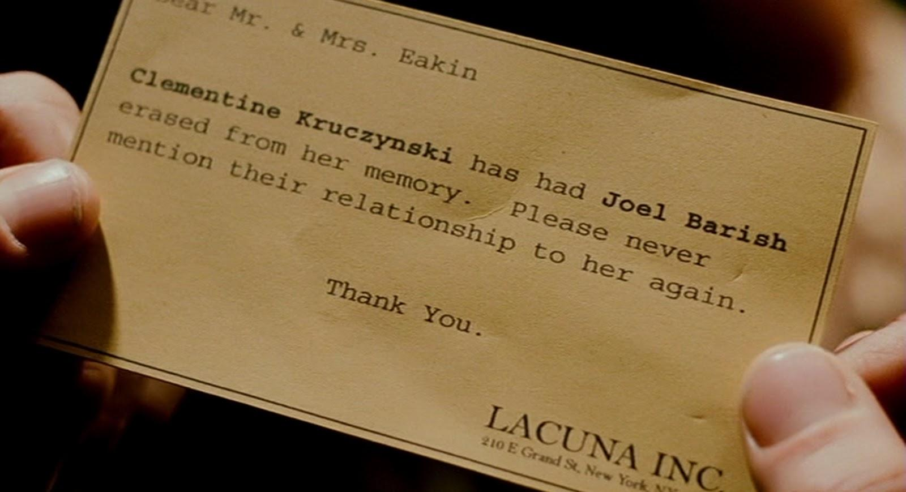
Would you do it?
Do you think other people would do it?
Do you think they should? Why or why not? Support your position with examples.

