Interior Monologue Final Assessment

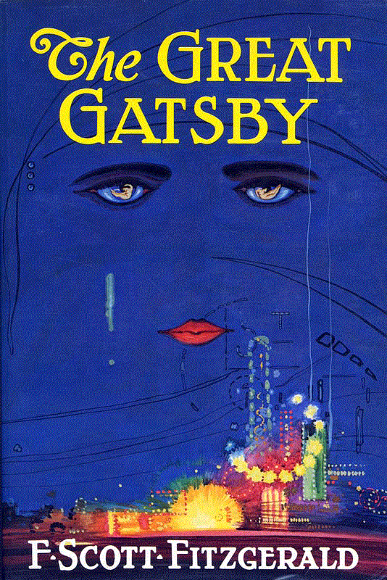
Throughout our study of The Great Gatsby, you have been evaluating how the author develops characters and uses them to reveal themes. You have traced your character's progression throughout the book and you have had a chance to delve into your character's thoughts and motivations.

Part 1: Write an Interior Monologue (50 pts)

Select a, "Hot Spot" for your assigned character. Think about the facets of his/her personality that help reveal theme. For example, if you think a prominent theme is that living in the past will only bring unhappiness, you may want to look at Gatsby and Nick's conversation at the end of chapter six.

Write a one to two minute monologue (about one page) from the perspective of this character that shows how this character contributes to a theme of the novel.

Your monologue must include:
- A brief sentence of context, so your audience understands where in the novel your monologue is situated
- One line from the book that the character actually says that launches you into your monologue
- A connection to a pivotal theme of the novel
- One metaphor
- Carefully selected diction that reveals the tone of your piece

Part 2: Analyze Your Monologue (50 pts)

In two meticulously crafted paragraphs, explain the analytical choices you made while you constructed this monologue.

Your first paragraph should explain (with evidence from your text) what choices you made in your own writing. What diction did you use and how did it help convey your tone? What theme emerged as a result of your monologue and how did you develop it?

Your second paragraph should explain how your creative adaptation provides new insight into the text or the theme. How does your monologue's writing develop our understanding of the source text, The Great Gatsby? How does it alter or expand it to create a new or enhanced message?

