ACT & SAT Prep Vocabulary Study Cards

Research shows that vocabulary is closely linked to academic success. A strong vocabulary is essential to good reading and, because reading and writing are so closely related, essential to good writing. In addition, building your vocabulary will prepare you for the ACT or SAT.

We are going to use a study method called “Vocabulary Cards.” Research demonstrates that vocabulary study is most effective when you construct your own meaning and are able to visually represent a word and its related term. By closely looking at an individual word, you will be able to learn, in addition to its definition, a lot about the way that language works.

For each vocabulary term, you should produce one study card with the following information in the format shown:

- Divide the word into prefix, suffix, and root—not syllables. (Note: Not all words have prefixes and suffixes, but some have more than one prefix and/or suffix.)

- Find and list the meaning of each part of the word.

- Find and list three words with the same root. (This can usually be done by looking at words on the same dictionary page as the word, but you are encouraged to look around!) *If you cannot find these, just list SYNONYMS.

- Do a quick draw of the concept of the word, not the definition. (For example: A picture of the definition of the word pedestrian would be a person walking. A picture of the concept could be a foot.)

- At the bottom of the card, write the definition.

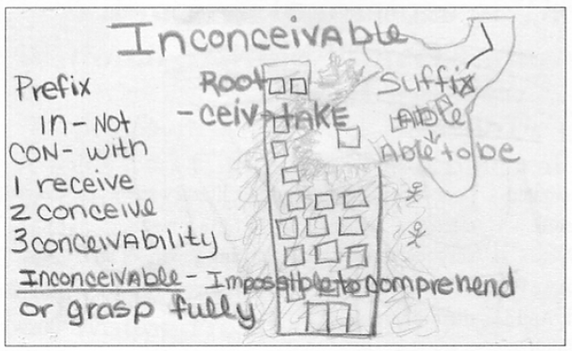

- On the opposite side of the card, write the part of speech and at least TWO sentences using your word. Be creative here and make sure you are writing sentences that give us a clue to the word’s meaning. If you need, find examples of the word used in a sentence “in the wild” before writing your own sample sentence.

- Quizzes will be every few weeks (1 or 2 a month). Each quiz will be worth 30 points and will test on words in fill-in-the-blank format (this is a format common on the ACT and SAT).

- For most quizzes, 10 questions will be on “new words,” and 5 questions will be on vocabulary terms from previous lists. Students are encouraged to go back and review their ALL their study cards frequently and regularly.

*Concept and sample image taken from “Visualizing Vocabulary” by Eileen Simmons.

