Name ________________________________________ Period ______

- Mark your confusion by highlighting or underlining anything you don’t understand.

- Show evidence of a close reading (questions, connections, predictions, reactions, summarizing, clarifying, challenging, etc.).

- Write a 1-page response.
Possible Writer’s Notebook questions:
- What do you think about using earnings to measure success?
- What impact does the article have on your outlook for high school?
- What do you think about the chart included in this article? Why do you think the author included it? What does it add to the article?
- Pick a word, sentence, or passage and respond to it.

High School Nerds Make More Money, Says Social Science
By Jordan Weissmann, Slate.com

At this point, I think most of us have come to appreciate that teenage nerdery can pay off handsomely later in life. But in case the money pouring into Silicon Valley or the cultural hegemony of Game of Thrones didn’t have you convinced, researchers at the University of Miami have now published a study showing that students who earn better grades in high school also make more money as adults.
The paper, which appears in the Eastern Economic Journal, finds that boys who up their GPAs by an extra point can expect to earn 11.85 percent more pay down the road. For girls, an additional grade point is worth a 13.77 percent bonus. This was after controlling for a host of demographic factors as well as a measure of innate smarts. The researchers based their finding on a longitudinal study that tracked thousands of Americans from adolescence through young adulthood. Crucially, the data included actual high school transcript information, not self-reported grades that could have been prone to misrecollection.
Here is a basic breakdown of how grades and GPA relate. (While the paper itself doesn’t chart the relationship exactly this way, the researchers prepared the data to share with the press.)
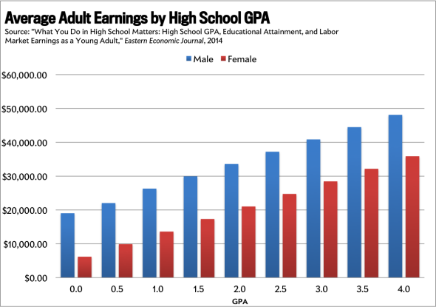
University of Miami economist Michael French, one of the report’s authors, told me that so far as he and his collaborators could tell, no studies had previously explored the long-term link between high school GPA and adult pay. Rather, researchers studying the influence of high school performance on future earnings have tended to look at things such as how many years of education students complete and what sorts of classes they take. He cautioned that while his paper's findings show a strong correlation between grades and pay, it doesn't prove a causal link. But it’s not difficult to think of ways pay and grades might relate. A student’s high school GPA is a good predictor of whether he will finish college, and generally, more education leads to more pay. The ability to slog through high school biology and Spanish class also may well just be a good indicator of intrinsic motivation.
In any event, between this paper and work from Yale showing that high school popularity apparently has no influence on adult pay, the nerds appear to have social science firmly on the side of their life decisions. And the next time your snot-nosed teen refuses to do his homework, you can now show him why he should, in one graph.

