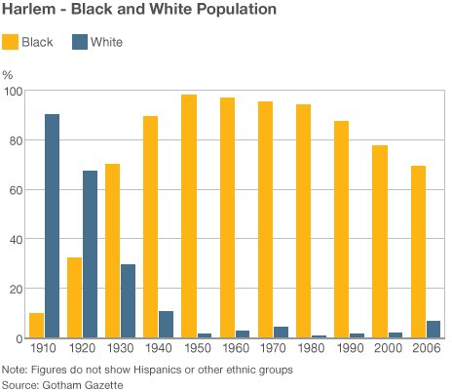

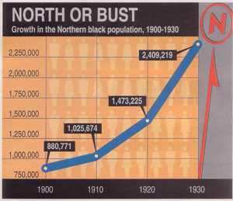

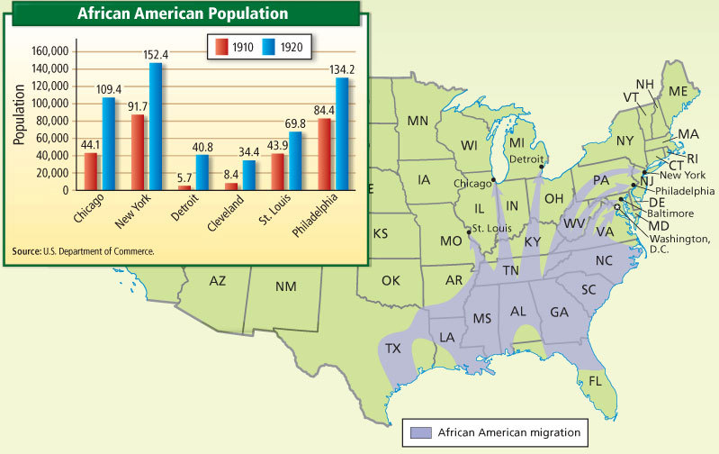

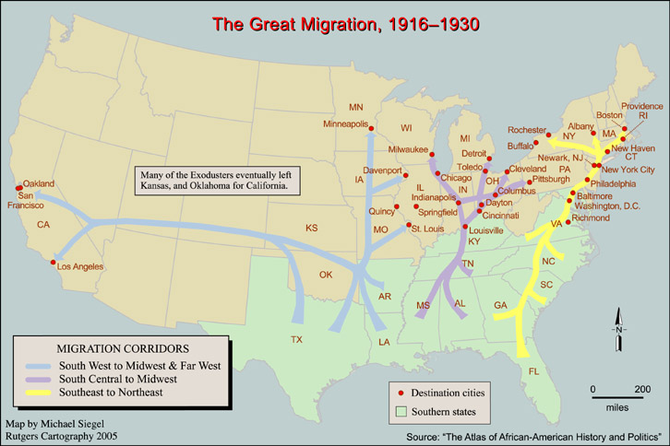

[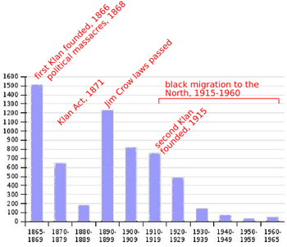](http://en.wikipedia.org/wiki/File:Linchamientos.png)

[http://bits.wikimedia.org/static-1.23wmf1/skins/common/images/magnify-clip.png](http://en.wikipedia.org/wiki/File:Linchamientos.png)

**Lynchings and racially motivated murders in each decade from 1865 to 1965.**

