Name: _________________________ Period: _____
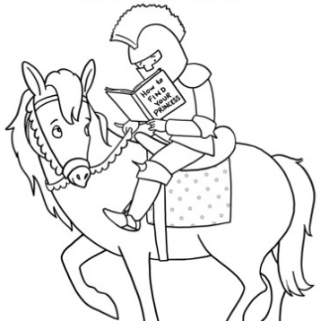
My “Go To” Reading List
Spend the rest of the class period compiling a list of potential books you could read for the reading challenge. You’ll notice there are specific tasks that you must do so that your list is rich with variety. Just because you write a book down doesn’t mean you have to read it as part of the challenge. This is a tool for you to use if you get stuck and don’t know what to read next. Complete this by the end of the period and turn it in to Mrs.Craft. (You will get these back next week.)
Pick at least 3 genres and use the book introductions to find at least 5 books that look interesting (include genre and title).
Genre Title Author
1.________________ _______________________________ ____________________
2.________________ _______________________________ ____________________
3.________________ _______________________________ ____________________
4.________________ ______________________________ ____________________
5.________________ _______________________________ ____________________
6.________________ _______________________________ ____________________
7.________________ _______________________________ ____________________

Get recommendations from at least 5 different classmates (include title and classmate recommending the book).
Title Who Recommended It?
1.____________________________________________ _______________________
2.____________________________________________ _______________________
3.____________________________________________ _______________________
4.____________________________________________ _________________________
5.____________________________________________ _________________________
6.____________________________________________ _________________________
7.____________________________________________ _________________________

List at least 3 interests and find a nonfiction book on at least 1 of these topics.
Interest Title Author
1._________________ ______________________________ ___________________
2._________________ ______________________________ ___________________
3._________________ ______________________________ ___________________

Use a book recommendation site such as whatshouldireadnext.com or yournextread.com to find at least 3 books that are similar to a book you have enjoyed before (include title and author).
Title Author
1.______________________________________________ _______________________
2.______________________________________________ _______________________
3.______________________________________________ _______________________
4.______________________________________________ _______________________
5.______________________________________________ _______________________

Browse the Library—the shelves, the lists, etc. to find at least 3 other potential books
Title Author
1.________________________________________________ _____________________
2.________________________________________________ _____________________
3.________________________________________________ _____________________
4._________________________________________________ ____________________
5._________________________________________________ ____________________

