DBQ

Document Based Question

Prompt: Read the following sources. Then, in an essay that utilizes at least three of the sources, take a position on whether students should be required to speak in front of a class or not. Be sure to take into account sources that are oppositional to your view.

Skill | Completed
Annotate sources
Form a great thesis/claim
Outline paragraphs
- Introduction
- 2 TEXT paragraphs
- Concession
- Conclusion

Source 1: Your English teacher is required to teach you the following skill.
Source: Common Core Standards.
CCSS.ELA-LITERACY.SL.9-10.4
Present information, findings, and supporting evidence clearly, concisely, and logically such that listeners can follow the line of reasoning and the organization, development, substance, and style are appropriate to purpose, audience, and task.

Source 2: You see this cartoon shared on Facebook.

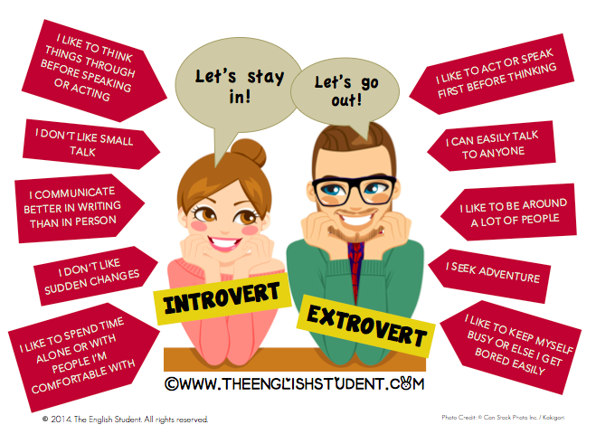

Source 3: You overhear someone talking about this article.
Source: “Students Shouldn’t Have to Speak in Front of the Class.” Geekdad.com. Nov 2, 2014.

I’ve been saying this for over 35 years, since the first time my teacher made us all participate in Show and Tell. I hated speaking in front of people then, and I hate doing it now. In between, I hated being called on when my hand wasn’t raised, which some teachers did to try to encourage more participation. But all it succeeded in doing was to make me fear those classes and to be so busy worrying that I wasn’t learning. I hated oral presentations. I hated having to be the spokesperson for group work. I hated anything that caused me to be the center of attention for more than a couple of people at a time.

Source 4: An article your parents give you as a hint to get a job.
Source: “Five Skills College Grads Need to Get a Job.” USA Today. May 3, 2015.
Oral communication is [an]area where employers say that recent graduates need help. Forty-one percent of employers say the young people they’re looking to hire lack this skill. Given that this generation has grown up in a world where digital communication is the norm, it’s not surprising that some may struggle with more traditional ways of sharing information.
Struggles with verbal communication for young graduates go beyond not being able to give a polished presentation or answer the phone (the latter is a task that many of them would prefer to avoid). Recent graduates may also not understand how to adjust their speaking style in different situation A style that is perceived as too casual or laid back can be a big turnoff to employers, especially those in more conservative industries.

Source 5: A tweeted picture.

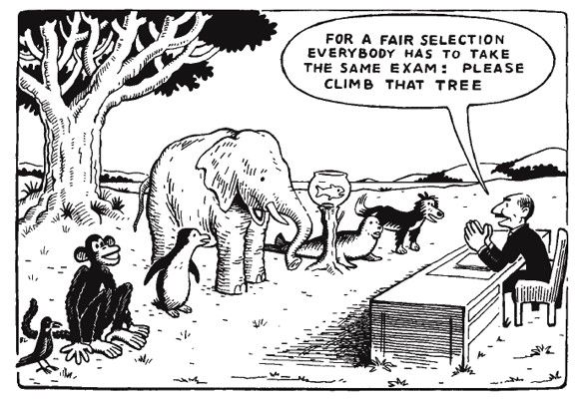

Source 6: You hear radio talk show hosts mention this article.
Source: Schultz, Katherine. “Why Introverts Shouldn’t Be Forced to Talk in Class.” The Washington Post. Web. March 10, 2016.
“Jessica Lahey, a high school teacher and writer, argues in the Atlantic magazine that introverts should be required to speak in class. She claims that classroom participation grades are not only fair but are necessary….She suggests that in order to be successful in today’s world, it is imperative that introverted students be taught and coerced through grades and expectations to participate in class.
I disagree. Lahey paints students who are quiet in her class with a broad brush, calling them all “introverts.” The truth is that there are many reasons students may choose not to verbally participate in school. Some students are painfully shy and perhaps even introverts. Other students choose their moments to speak carefully, participating in silence for long periods before they decide to speak aloud. Some are quiet in school and loud in other contexts. Sometimes a student’s silence protects her from ridicule or bullying. In many cultures, silence is a sign of deep respect and more highly valued than talk. I would argue that Lahey’s advocacy for grading or counting classroom participation ignores the value and uses of silence in the classrooms, overlooking the myriad of other ways students participate.”

Source 7: An article read in your English class.
Source: Lahey, Jessica. “Introverted Kids Need to Learn to Speak Up at School.” The Atlantic. Feb 7, 2013.

(Edited for Length)

The parents of introverts complain that I am causing serious emotional trauma by requiring their child to speak up in school.

I am aware that as an extrovert, I naturally teach to extroverts. Consequently, I have worked very hard to research and implement teaching strategies that work for introverted students. I have a personal interest in the subject as well, as I am married to one introvert and mother to another.

I gathered a towering pile of books on my nightstand, topped by Susan Cain's book Quiet: The Power of Introverts in a World that Can't Stop Talking. In her book, Cain champions the often-overlooked talents and gifts of introverts, and offers parents and educators strategies for communication and evaluation.

In the end, I have decided to retain my class participation requirement. As a teacher, it is my job to teach grammar, vocabulary, and literature, but I must also teach my students how to succeed in the world we live in -- a world where most people won't stop talking. If anything, I feel even more strongly that my introverted students must learn how to self-advocate by communicating with parents, educators, and the world at large.

Dr. Kendall Hoyt -- introvert, assistant professor of medicine at Dartmouth Medical School -- agrees. "You don't get a pass for your personality type. I understand that social anxiety is a real thing, but part of my job as a teacher is to teach people how to articulate and be heard."

Hoyt applies this same philosophy to her own children, both introverts. She and her babysitter have constructed elaborate social scavenger hunts for the children, games that require them to approach strangers, look them in the eye, and ask for whatever the game requires - directions, information, or signatures.

When I asked her why she puts so much effort into her children's ability to communicate with strangers, she answered, "In order to be effective in this world, you must be able to communicate. If you can't speak up for yourself, if you can't muster the courage to tell the person you love that you love them, if you can't advocate for your own safety, the world will be a very intimidating and frightening place. I don't want my kids to be intimidated by the world."

It's important - even imperative - to speak up for one's self. Cain starts her book Quiet with the example of Rosa Parks and the historic "No" she gave the bus driver who asked her to move to the back of the bus. Cain reports that, according to her obituary, Parks was an introvert. And yet that introvert spoke up and claimed her rightful place in the world. In honor of Rosa Parks, Susan Cain, and the many introverted students under my tutelage, I will continue to encourage them to find their voices.

