DBQ

Document Based Question

Prompt: Read the following sources. In 2–3 body paragraphs that utilize at least three of the sources, take a position on whether Pokémon Go is beneficial to society and individuals.

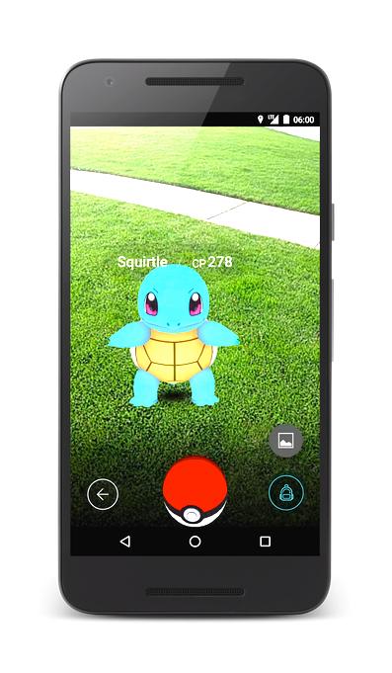

Source 1: You hear about a new game and look it up.
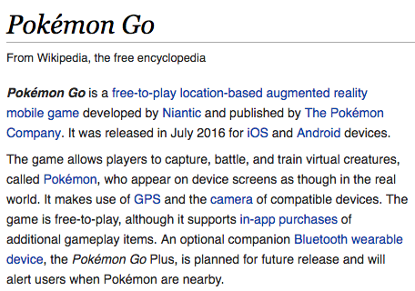

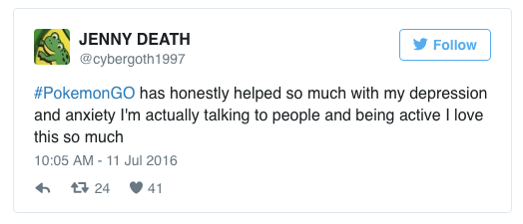
Source 2: You see these comments on Twitter.

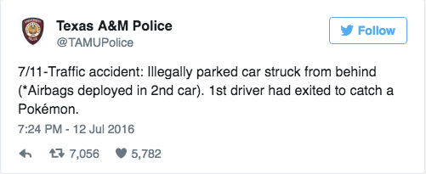

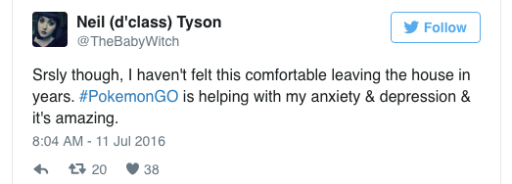

Source 3: You see this article in a psychology magazine.
Source: Marlynn, Wei. “The Psychological Pros and Cons of Pokémon GO.” Psychology Today. 2016, July 12. Web.

Pros
- The game is structured with clearly defined goals and step-wise levels. Clear structure, immediate feedback, and attainable goals are all very helpful, especially for those with depression, to keep people interested and engaged. A lack of structure can keep people with low energy, fatigue, lack of motivation, and depressed mood in a rut. By creating incremental goals, the game encourages feelings of effectiveness and moving forward.
- It's an easy conversation-starter and can help ease social anxiety. Social anxiety and depression are commonly marked by being socially withdrawn and feeling uncomfortable around other people. This game has the flexibility to let you play alone but also to be around other people, so it gives you a way out if you want it but also the option to interact with others over something you share in common, so it's low risk interaction.
- It encourages walking by giving you an incentive to discover and collect new Pokémon and balls to catch them—and it requires you to walk certain distances to hatch "eggs" that you collect. Physical exercise is known to effectively aid depression and overall health, and the app is a useful incentive to go out and walk more.
- The blending of reality and fantasy can spark your creativity and childhood imagination. Finding cartoons popping up in the middle of buildings and streets can make you feel like a kid, and the app allows you to create some fun and creative photos.
Cons
- Playing the app makes you more distracted. The app itself features a disclaimer cautioning you to be alert and aware of where you’re going while you’re playing, but there have already been reports of injuries incurred when playing the game. It does put the mind into a blended reality state, in which you’re not quite in the real “present moment” since your eyes are focused on the phone looking at something that isn’t actually there in reality.
- The game puts you in a heightened "stressed" state. Since you’re technically trying to find and catch something, your body is most likely in a fight-or-flight state, meaning your adrenaline is pumping and your heart rate is a bit higher than usual. For a short period, this can be fun, but long-term, you can experience fatigue and feel more worn out, so it’s important to take breaks and make sure you’re not experiencing side effects of excessive gaming.
- The game could cause you to spend more time on your phone and make you less social. Playing the game could actually make you less social and increase the time you're on your phone and not interacting with people "IRL." But this will vary based on an individual's experience.

Source 4: You overhear someone talking about this article.
Source: Haelle, Tara. “Five Ways Pokémon Go is Actually Good for You.” Forbes. 2016, July 11. Web.

Along with the game’s explosive popularity have come strange stories—like stumbling onto a dead body while searching for water-dwelling Pokémon—and cautions about the physical risks of playing. That opening screen warning you to be aware of your surroundings is no joke: armed robbers have taken advantage of absorbed, wandering Pokémon players, and it’s easy to trip, sprain an ankle, fall into a ditch, walk into a door (or a road sign), hit your head, bust open an elbow or otherwise injure yourself if your eyes are glued to your phone while you’re tracking the little critters. (The Oregonian offers some obvious tips on how to avoid injury while playing.) And while no Pokémon-related car accidents have been reported yet, it’s almost certainly just a matter of time.

Source 5:
Source: Akhtar, Allana. “Holocaust Museum, Auschwitz want Pokémon Go Hunts Out.” USA Today. 2016, July 13. Web.

Officials at the Holocaust Museum and Poland's Auschwitz Memorial are calling on Pokémon Go maker Niantic to take their sites off the locations where players can hunt cartoon creatures in the popular augmented reality app, saying it dishonors Holocaust victims.

Andrew Hollinger, the United States Holocaust Memorial Museum's communication’s director, said Pokémon Go is not appropriate for a memorial dedicated to the victims of Nazism… “Technology can be an important learning tool, but this game falls far outside our educational and memorial mission,” Hollinger said in a statement to USA TODAY.

Rabbi Abraham Cooper, associate dean of The Simon Wiesenthal Center, said while he recognizes the potential for good virtual reality may bring – such as interviewing Holocaust survivors and potentially using them for holograms – there should be a line drawn when it comes to using memorial sites in games. "This can't be another chapter, it can't be another scavenger hunt. That's a desecration of the memory of the victims and it's a cheapening of the history," Cooper said of using the Holocaust Memorial Museum for gaming.

Source 6: Someone shared this story online.
Source: Bowerman, Mary. “Children’s hospital using ‘Pokémon Go’ to get patients out of bed.” USA Today. 2016, July 15. Web.

A Michigan children’s hospital is using Pokémon Go as a tool to get sick patients out of their rooms and interacting with fellow patients and hospital staff. In the past, young patients at C.S. Mott Children’s Hospital in Ann Arbor, Mich., shuffled down the hallways without speaking to each other, but now it’s not uncommon to see them stop and talk near a Pokémon Go hotspot, according to J.J Bouchard, digital media manager, and certified child life specialist at the hospital.

“It’s a fun way to encourage patients to be mobile,” Bouchard said. “This app is getting patients out of beds and moving around.” Pokémon Go is an augmented reality game that accesses a smartphone's GPS and camera to allow players to explore their surroundings in search of more than 100 Pokémon creatures. Features within the game include "Poke stops" — where users collect items they can use — and gyms, which are larger landmarks that users battle to control.

But while Mott Children’s Hospital hasn’t had any issues with people playing on campus, other hospitals have banned Pokémon Go. In Springfield, Mo., the two main health systems are asking members of the public to stop playing the game on their campuses — and one specifically requested employees on the job cease trying to "catch 'em all," the Springfield News-Leader reported. Bouchard said the hospital is aware that other facilities have had negative experiences with Pokémon Go, and people have wandered into areas where they shouldn’t.

Source 7: You overhear someone talking about this article.
Source: Nakashima, Ryan and Anderson, Mae. “Property Owners: Get off my lawn, Pokémon!” The Washington Post. 2016, July 13. Web.

As throngs of “Pokémon Go” players traipse around to real-world landmarks in pursuit of digital monsters, some ticked-off property owners are asking to have their locations in the fictional Poke-verse removed.
Ryan Calo, a University of Washington law professor, said private property owners may adopt a “Pokémon No Go” policy and bar players from physically entering their building or grounds. But he said there’s no legal right to compel the game’s creators to remove a location from its lines of code.
“It’s important to note that the Pokémon are not there on the property,” he said. “What’s happening is that a particular location triggers the display of a digital monster on your phone. The monster is only on your phone.”

