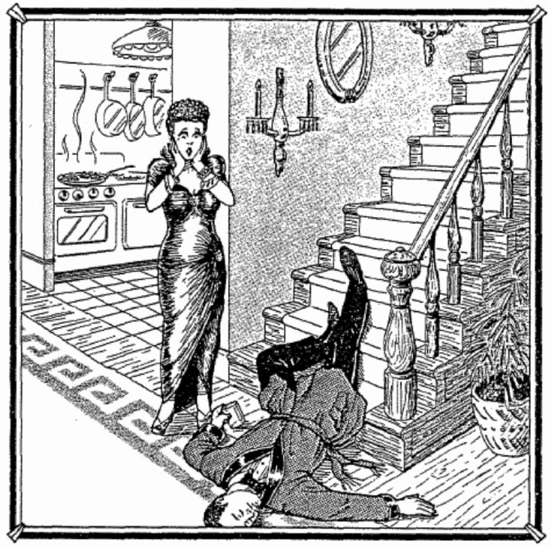
Evidence | Implication

Officer report
I walked into the scene in Mrs. Volupides’ living room shortly after one in the morning and took in the sight of a shocked woman standing over her lifeless husband who was lying at the foot of the staircase. According to Mrs. Volupides, her husband had fallen down a flight of stairs while coming down for another drink.
I asked Mrs. Volupides to please explain her story. She told me that she had gotten into a bit of a quarrel with her husband, Mr. Volupides, and went to the country club, where there was a party going on. After settling down and having a few drinks with her friends at the country club, she decided that she would invite them over for one last drink.
Mrs. Volupides had arrived ten minutes before her guests, and it was during this time at home that she discovered Mr. Volupides lying supine at the foot of the stairs. When her friends arrived, Mrs. Volupides exclaimed to them what happened.

Evidence (Detail) | Implication (What it Suggests)

