Names _____________________________________________

If We Wanted to Analyze A… | Movie 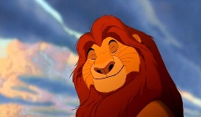  (like The Lion King)
List of Features We Could Analyze
Purpose for Analysis (Why would anyone want to analyze this? What would they want to understand?)

Names _____________________________________________

If We Wanted to Analyze A… | Video Game  (like Minecraft)
List of Features We Could Analyze
Purpose for Analysis (Why would anyone want to analyze this? What would they want to understand?)

Names _____________________________________________

If We Wanted to Analyze A… | Sporting  Event  (pick a sport)
List of Features We Could Analyze
Purpose for Analysis (Why would anyone want to analyze this? What would they want to understand?)

Names _____________________________________________

If We Wanted to Analyze A… | 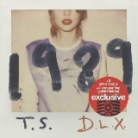  Music Album  (like 1989)
List of Features We Could Analyze
Purpose for Analysis (Why would anyone want to analyze this? What would they want to understand?)

Names _____________________________________________

If We Wanted to Analyze A… | 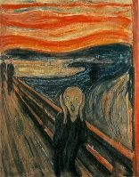  Art Piece  (like The Scream)
List of Features We Could Analyze
Purpose for Analysis (Why would anyone want to analyze this? What would they want to understand?)

Names _____________________________________________

If We Wanted to Analyze An… | 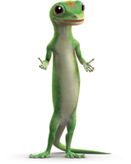  Advertisement  (like a Geico  commercial)
List of Features We Could Analyze
Purpose for Analysis (Why would anyone want to analyze this? What would they want to understand?)
Names _____________________________________________

If We Wanted to Analyze A… | 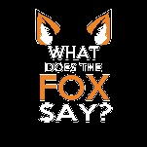  Viral Video  (like What Does the Fox Say?)
List of Features We Could Analyze
Purpose for Analysis (Why would anyone want to analyze this? What would they want to understand?)

Names _____________________________________________

If We Wanted to Analyze A… | Story  (like Cinderella)
List of Features We Could Analyze
Purpose for Analysis (Why would anyone want to analyze this? What would they want to understand?)

