Maya Angelou pp. 50, 151-152

Maya Angelou Biography
Poet, Author, Civil Rights Activist (1928–2014)
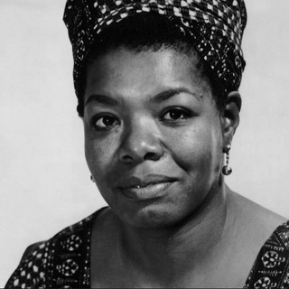

Maya Angelou is a poet and award-winning author known for her acclaimed memoir I Know Why the Caged Bird Sings and her numerous poetry and essay collections. I Know Why the Caged Bird Sings made literary history as the first nonfiction best-seller by an African-American woman.

Multi-talented barely seems to cover the depth and breadth of Maya Angelou's accomplishments. She was an author, actress, screenwriter, dancer and poet. Born Marguerite Annie Johnson, Angelou had a difficult childhood. Her parents split up when she was very young, and she and her older brother, Bailey, were sent to live with their father's mother, Anne Henderson, in Stamps, Arkansas. As an African American, Angelou experienced firsthand racial prejudices and discrimination in Arkansas. She also suffered at the hands of a family associate around the age of 7: During a visit with her mother, Angelou was raped by her mother's boyfriend. Then, as vengeance for the sexual assault, Angelou's uncles killed the boyfriend. So traumatized by the experience, Angelou stopped talking. She returned to Arkansas and spent years as a virtual mute.

As an adult, Angelou wrote several autobiographies throughout her career, including All God's Children Need Traveling Shoes (1986) and A Song Flung Up to Heaven (2002), but 1969's I Know Why the Caged Bird Sings continues to be regarded as her most popular autobiographical work.

Excerpted from biography.com
The Scarlet Letter pp. 100-102
The Scarlet Letter Summary
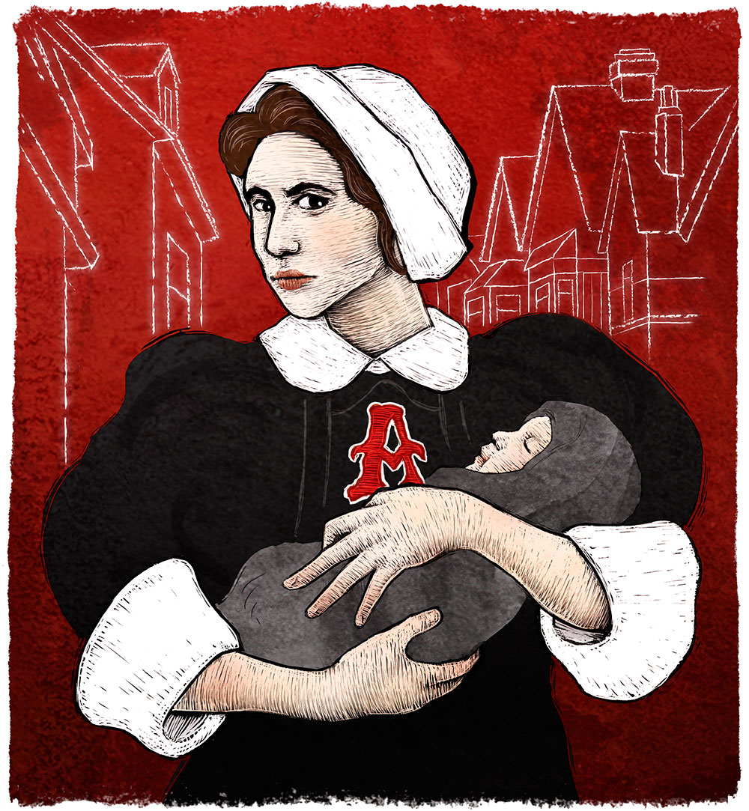

The Scarlet Letter is a novel by Nathaniel Hawthorne, published in 1850. It is considered a masterpiece of American literature and a classic moral study.

The novel is set in a village in Puritan New England. The main character is Hester Prynne, a young woman who has borne a child out of wedlock. Hester believes herself a widow, but her husband, Roger Chillingworth, returns to New England very much alive and conceals his identity. He finds his wife forced to wear the scarlet letter A on her dress as punishment for her adultery. Chillingworth becomes obsessed with finding the identity of his wife’s former lover. When he learns that the father of Hester’s child is Arthur Dimmesdale, a saintly young minister who is the leader of those exhorting her to name the child’s father, Chillingworth proceeds to torment the guilt-stricken young man.

In the end Chillingworth is morally degraded by his monomaniacal pursuit of revenge; Dimmesdale is broken by his own sense of guilt, and he publicly confesses his adultery before dying in Hester’s arms. Only Hester can face the future bravely as she prepares to begin a new life with her daughter, Pearl, in Europe.

Excerpted from britannica.com
Dracula p. 41

Dracula Summary

Dracula is a Gothic novel by Bram Stoker, published in 1897. The most popular literary work derived from vampire legends, Dracula became the basis for an entire genre of literature and film.

Count Dracula, an “undead” villain from Transylvania, uses his supernatural powers to lure and prey upon the innocent victims from whom he gains the blood on which he lives. The novel is written chiefly in the form of journals kept by the principal characters—Jonathan Harker, who contacts the vampire in his Transylvanian castle; Harker’s fiancée (later his wife), Mina, adored by the Count; the well-meaning Dr. Seward; and Lucy Westenra, a victim who herself becomes a vampire. The doctor and friends destroy Dracula in the end, but only after they have driven a stake through Lucy’s heart to save her soul.

Dracula combined central European folktales of the nosferatu, or undead, with historical accounts of the 15th-century prince Vlad the Impaler, who allegedly impaled 100,000 victims and was given the epithet Dracula (a derivative of Romanian drac, or “devil”).

Excerpted from britannica.com

Suffragettes pp. 154-156
Suffragettes
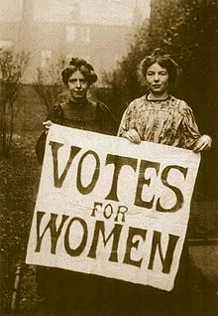

The women’s suffrage movement (aka woman suffrage) was the struggle for the right of women to vote and run for office and is part of the overall women’s rights movement. In the mid-19th century, women in several countries—most notably, the U.S. and Britain—formed organizations to fight for suffrage. In 1888, the first international women’s rights organization formed, the International Council of Women (ICW). Because the ICW was reluctant to focus on suffrage, in 1904 the International Woman Suffrage Alliance (IWSA) was formed by British women’s rights activist Millicent Fawcett, American activist Carrie Chapman Catt, and other leading women’s rights activists.

On Election Day in 1920, millions of American women exercised their right to vote for the first time. It took activists and reformers nearly 100 years to win that right, and the campaign was not easy: Disagreements over strategy threatened to cripple the movement more than once. But on August 26, 1920, the 19th Amendment to the Constitution was finally ratified, enfranchising all American women and declaring for the first time that they, like men, deserve all the rights and responsibilities of citizenship.

Excerpted from history.net and history.com

Gregor Mendel pp. 146-148
Gregor Mendel
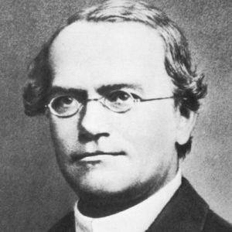

Ever wonder why you are the only one in your family with your grandfather's nose? The way in which traits are passed from one generation to the next-and sometimes skip generations-was first explained by Gregor Mendel. By experimenting with pea plant breeding, Mendel developed three principles of inheritance that described the transmission of genetic traits, before anyone knew genes existed. Mendel's insight greatly expanded the understanding of genetic inheritance, and led to the development of new experimental methods.

Our modern understanding of how traits may be inherited through generations comes from the principles proposed by Gregor Mendel in 1865. However, Mendel didn't discover these foundational principles of inheritance by studying human beings, but rather by studying Pisum sativum, or the common pea plant. Indeed, after eight years of tedious experiments with these plants, and—by his own admission—"some courage" to persist with them, Mendel proposed three foundational principles of inheritance. These principles eventually assisted clinicians in human disease research. Today, whether you are talking about pea plants or human beings, genetic traits that follow the rules of inheritance that Mendel proposed are called Mendelian.

Excerpted from nature.com

