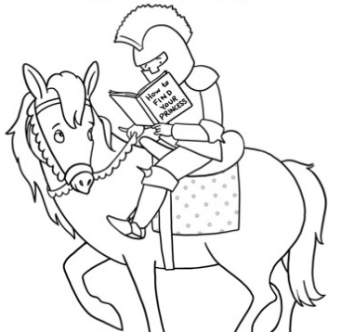
My Reading Challenge 2016—2017
Name: ________________________
Class Period: _________

Term 1 Goal:

How I Did:

Term 2 Goal:

How I Did:

Term 3 Goal:

How I Did:

Term 4 Goal:

How I Did:

Reading Record
Book Title | Author | Genre | # of Pages | Term
1
2
3
4
5
Book Title | Author | Genre | # of Pages | Term
6
7
8
9
10
11
12
13
14
15
16
17
18
19
20
21
22
23
24
25
26
27
28
29
30

